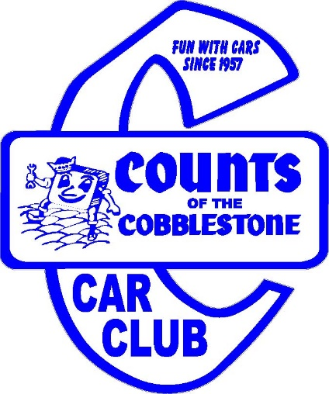
Name _________________________________________________________
Address _______________________________________________________
City_______________________ State ________ Zip _________________
Cell __________________________ Phone ___________________________
E-Mail _________________________________ Birth Date ____/____/_____
Employer or type of work __________________________________________
Significant Other’s Name ___________________________________________
Did you ever belong to a car club? ⃝ Yes ⃝ No
If so, when, and where ___________________________________________________________________________
Did you hold an office? ⃝ Yes ⃝ No
Why would you like to join the Counts? _________________________________________________________
____________________________________________________________________________________________________________________________________________________________________________________

Requirements… You must own a Street Rod or Street Machine, (finished or work in progress)
Year, Make, Model Condition Please list additional Rods or Machines on back.
___________________________ ____________________________________________________________
___________________________ ____________________________________________________________
___________________________ ____________________________________________________________

Fees include a membership card, windshield decal, current member listing, pro-rated membership till end of year first year, and subscription to National Street Rod Association (NSRA) along with its monthly publication (Street Scene).
To apply you must attend a meeting, fill out an application, pay the prorated amount for annual dues, pay for subscription to NSRA, have a Street Rod or Street Machine (currently running or in project stage), and be voted in by majority vote.
Dues are $60 per year and are due by the end of the first month of the new year.
Initiation Fee: $10 $__________
Counts Dues: $60 (prorated for number of months left in year) $__________
Total due with application (make check payable to Counts Car Club) $__________
NSRA subscription: $35 (make check payable to NSRA)

Applicant Signature: ________________________________________________ Date: ________________
For meeting times and locations contact Larry at 605-381-8997
or visit www.countscarclub.com

