The Streetin News Counts Car Club April 2023 newsletter
Since 1957 “Fun with Cars” Our 66th Year
In this IOooo ooo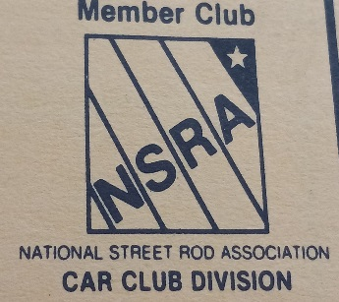LLarrttnn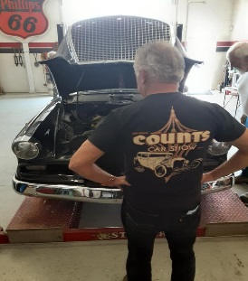
The Prez Says : This spot will be dedicated comments from our President,Peter MacDonald.Currently Pete is taking care of business at home and at work,but look for his wisdom posted here in the future. Pete lead us to the best attended and largest car show we have had date and has shown stellar leadership,communications with the Car Show Committee and the club. Great job Pete !!
NSRA News : Vice President Larry Raterman has recently accepted the NSRA State Representitive SD position. Watch here for more current updates with NSRA. Our annual NSRA inspection day will be coming up soon ,watch for the date .Great Job Larry !!
Member Spotlight : Terry Broadley
Pleased to have Terry, also known as Terrance Snotrkt as a valuable Counts member ! Terry keeps the Mustang tradition in his family going.
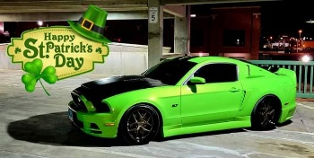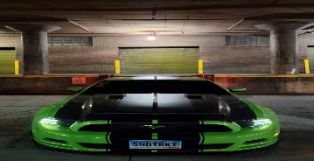
Terrys pops , Dennis Broadley was a potent force in drag racing at the Belle Fourche drag strip with his Boss 302 Mach 1 , the Nasty Nag , then ran the Humpty Dumpty Enterprises Sprint car at Black Hills Speedway half mile up until about 1978. The Sprint car drivers of that era were a rough and rowdy bunch, with names like Concrete John Slagle , Buckin horse Jim Olson and Wild Bill Liebig ! Terry was able to get Pics of his dads Mustang in its current condition thru our CountsCarClub.com website that he set up for us !! Great Job , Terry !!
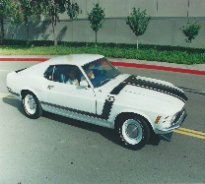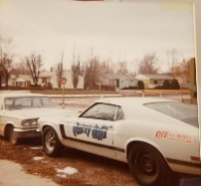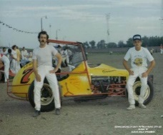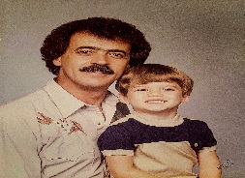

Sincerely, your Counts Car Club Communications Subcommittee

