The Streetin News Counts Car Club May 2023 newsletter
Since 1957 “Fun with Cars” Our 66th Year
In this IOooo oooLLarrttnn
The Prez Says : Special thanks to Rory Olson for arrainging Mangimaos Pizza in Hill City For our family night
NSRA News : With the nicer weather in May, the hibernating hot rods are starting to reappear from their winter garages. Nita and I traveled to Pierre with State Inspector Gary Kreun for NSRA inspection day for central South Dakota. The event was hosted by the Street Masters Car Club of Pierre and they did an excellent job. About 20 cars were inspected with only a few minor issues found, many we fixed on the spot. We visited with many of the club members and were very impressed with their organization of the event. After the inspection was over, we were treated to a barbeque meal and big thank you to all who prepared it.

Don't forget our NSRA Appreciation and Inspection Day coming up on May 21st at Steve Krogers from 10 till 4. More information for this event is on the bulletin board and in this newsletter. Your safety is Number 1 with the Counts! Get your cars inspected, you never know when a problem might exist that could endanger your safety and investment!

We are finalizing plans to attend the Mid-America Nationals in Springfield, Missouri the end of the month. There are several members of the club heading to this event, should be a great time! In 1974, I was stationed at Fort Leonard Wood just north of Springfield. I haven't been through that area since, so looking forward to seeing if I remember anything in that area.

This summer looks to be very busy, appears to be a local car show, rod run, parade or cruise night every weekend from now till October! So, stay safe on the road, get your cars safety inspected and I will see you on the road this summer! If you have any questions about NSRA, give me a call or grab me before or after Counts meeting. I will be happy to answer any questions you may have and if I don't have an answer, I will get one for you!

Larry
NSRA Rep
Counts official events :Cars and Coffee June 17th at our clubhouse
Featuring music by Kim and The Classics
Kim performs at our Car Show and our Greaser Dance and her husband Ron Plender is a legendary drag racer with his 6 cylinder powered Chevies. Ron is always at Sturgis Dragway and Julesburg Colorado races. Visit with him , he is awesome! Julesburg Hot Rod revival Gasser Drags is August 19 and 20 th this year.
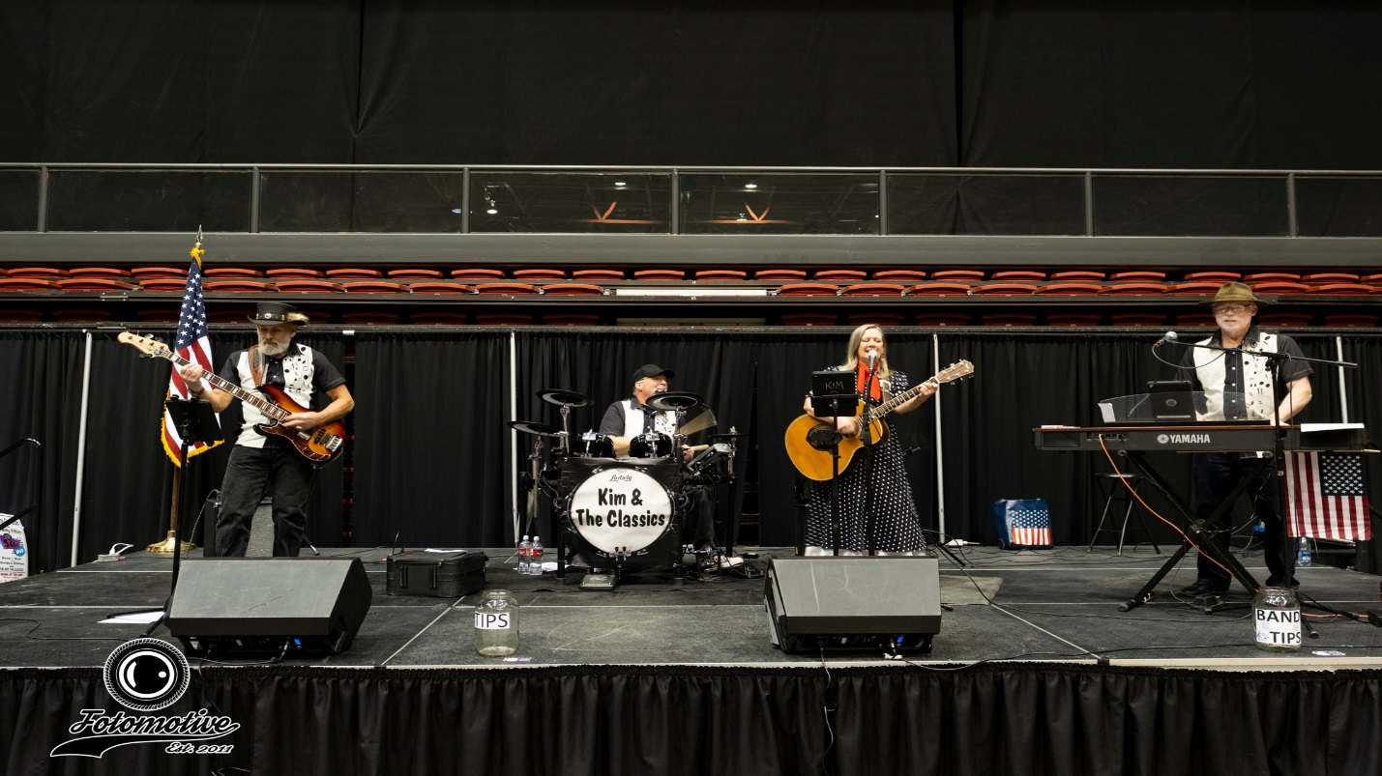
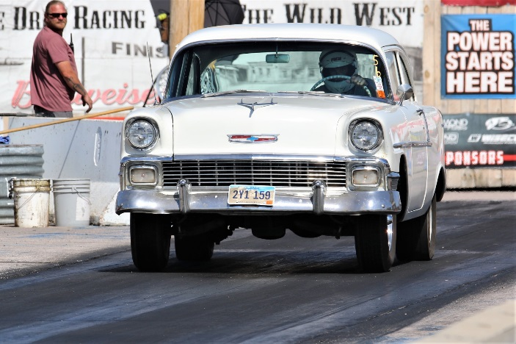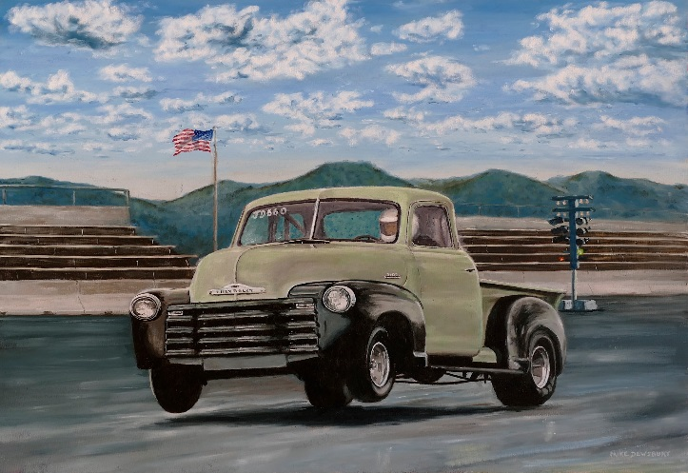

What is being built : Bob Rohrbach :1956 Chevrolet wagon ,came out of Minnesota, a 454 and Turbo 400 from a low milage motorhome is going in it. Looking good , Bobber !
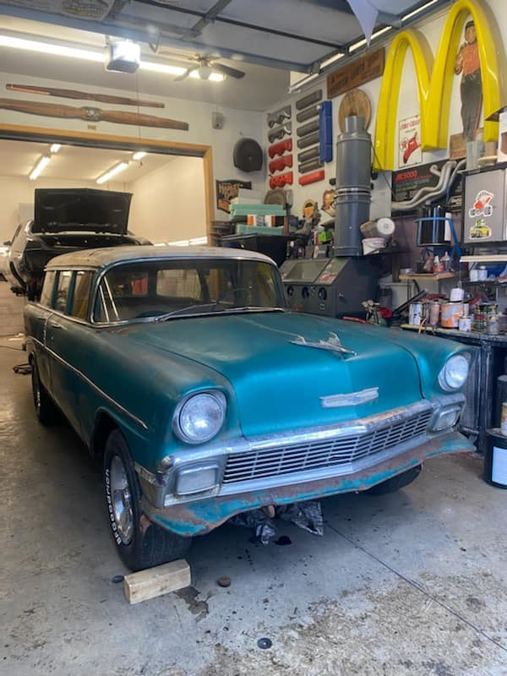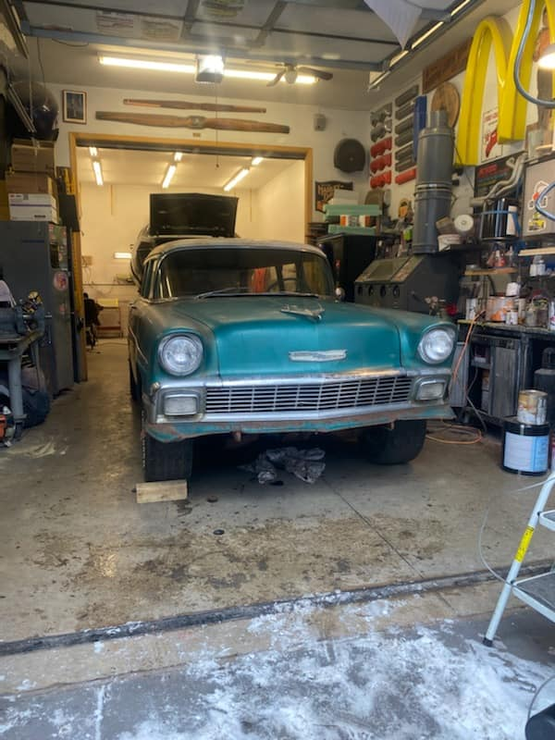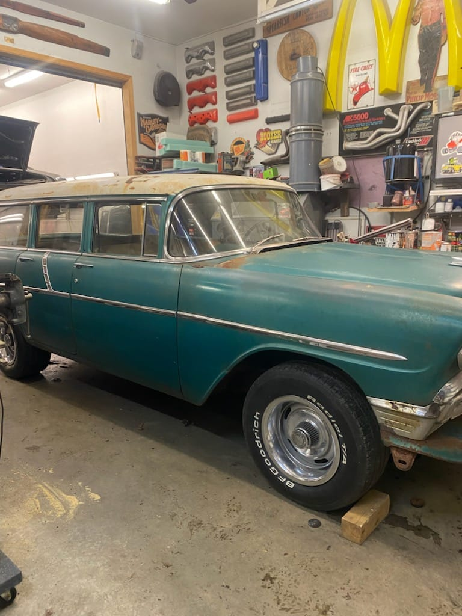
Counts travel to exotic places to help build hot rods:
Gary Kruen is In Texas helping Steve Lopez with an LS swap in a 66 Nova.
Steve had Performance Auto and Welding hot rod shop in 1989 thru 1995 and built many local cars and and was a Counts member and Club Officer. He the partnered with Gary in the Muffler Shop.
Steves other passion is Subaru engine swaps in Volkswagon Vans, the one pictured on the hoist is for a local brewery and carries beer kegs and taps !!
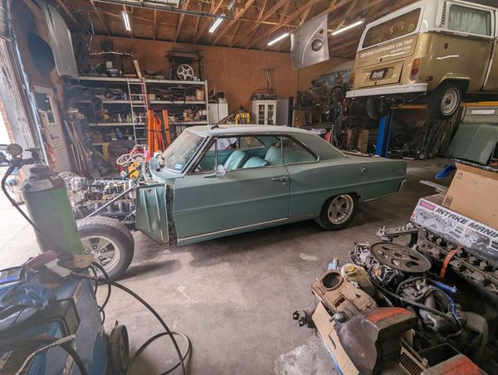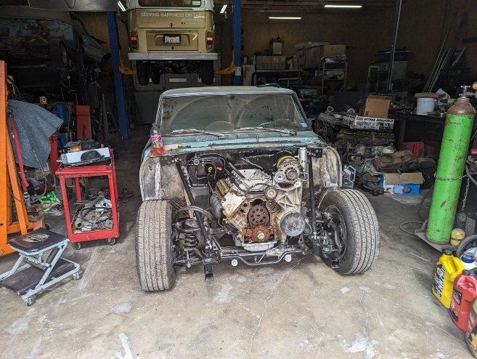

New Member Spotlight : Austin Harrison – Grew up on a farm in Texas during the 1960s. Just old vehicles then but always enjoyed driving them. “Hey baby, want to go for a ride in my truck?” A pickup line that actually worked back then. Then adulthood: jobs, marriage, Viet Nam. Entered the Air Force thinking only one term. Life happened, kids, bills, travel, adventure, commitment. Turned into an unintended career. Over twenty one years later l was separating from active duty. They call it retirement. (Retirement implies income without seeking additional work. Not so.) Most of my years on active duty, I desired to have an old vehicle again, But moving 11 times in 21 years was just not conducive to procuring, working on, or storing. I did eventually get an old Chevy, but it was a basket case and with my limited skills and lack of enough income to pay for restoration, it sat while I continued to work and dream. For the last several years, my wife urged me to either get it running or replace it with one already operable. She reminded me that my biological clock was ticking and my time of enjoying cruising was getting shorter every day. When she died in August 2021, I considered that this dream would also die. However, my family and closest friends encouraged me to follow her desire for me. I got rid of the old Chevy and bought a 1940 Ford pickup. Mostly in good shape. It will be a driver, never really had a desire for a show vehicle. After I solve a few problems and gain enough confidence that it will not leave me stranded somewhere, it will be more enjoyable to drive. Joined the Counts to develop contacts, and interact with others that enjoy old vehicles.
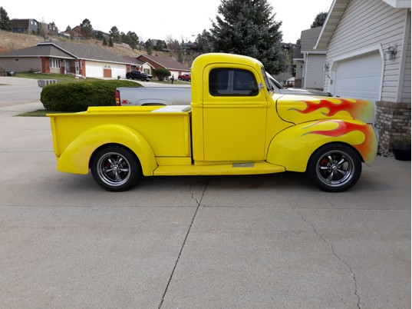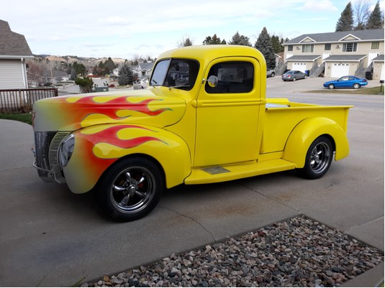
Counts in the community:
Counts Car Club and The Rathco band, a great combination!! The Rathco lead guitarist will be sporting a Counts car show shirt when they perform!! Tommy Relf has already booked this young and upcoming group to our car show for next year The Rocke Grace Foundation, in honor of their grandfather, raises money to buy instruments for elementary school children.
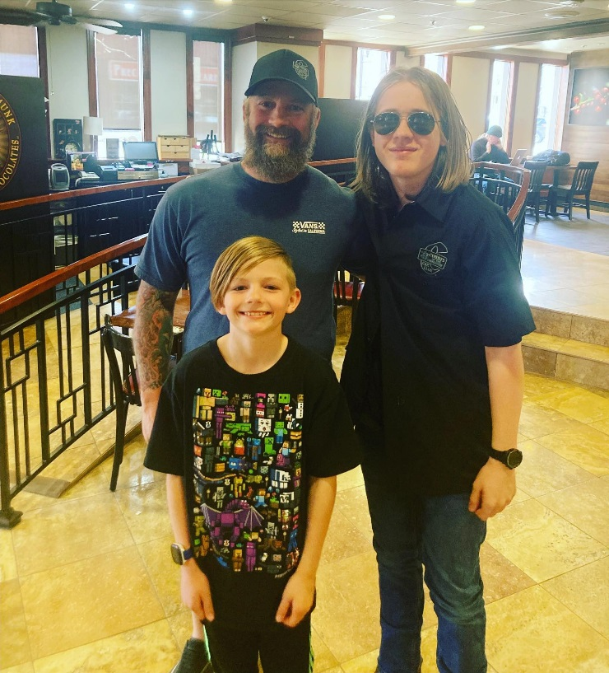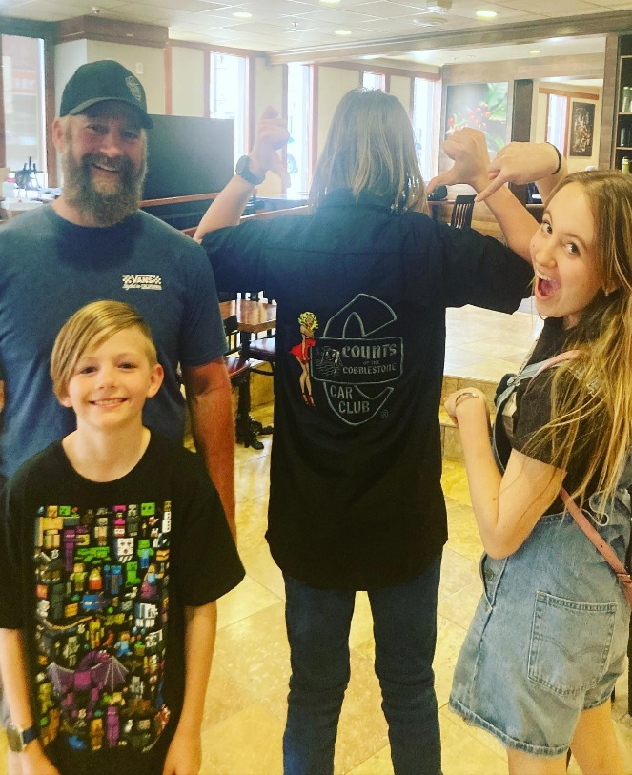

For many years Counts Car Club has sponsored Carly Joe Dales Drag Racing efforts.
Carly and her husband Joe Dale just welcomed a new addition to their Drag racing family:
Wylee Lane Dale
May 7th, 2023, 8:25pm
Congradulations from the Counts Car Club !!!
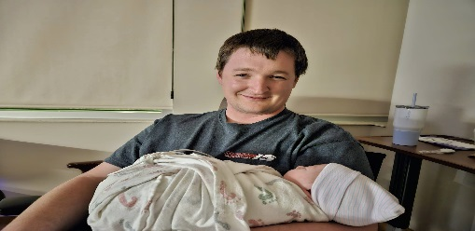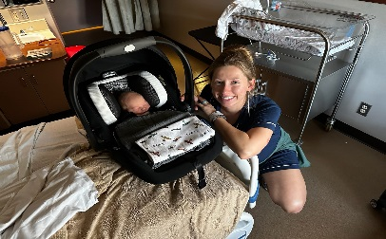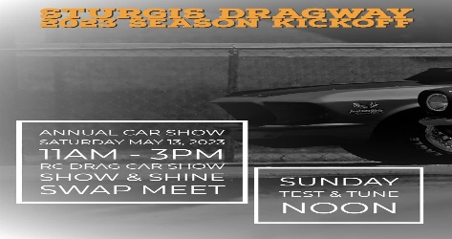
Upcoming events and Vendor News:
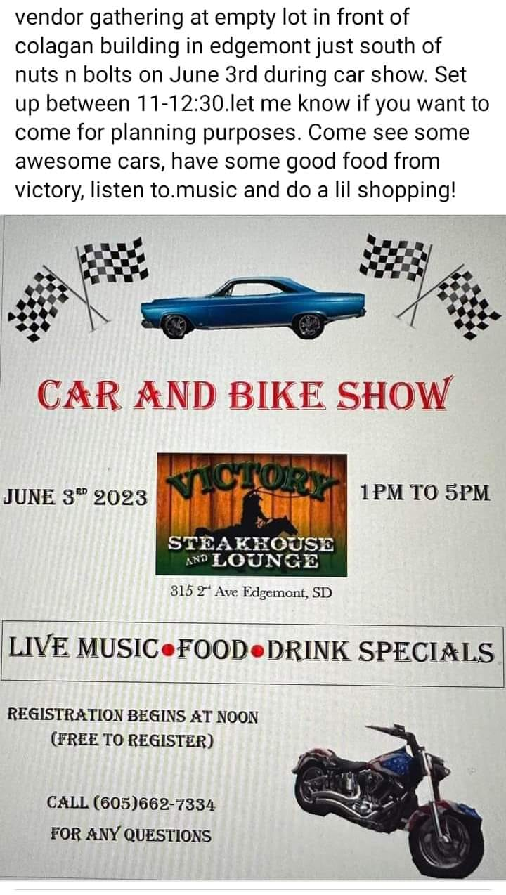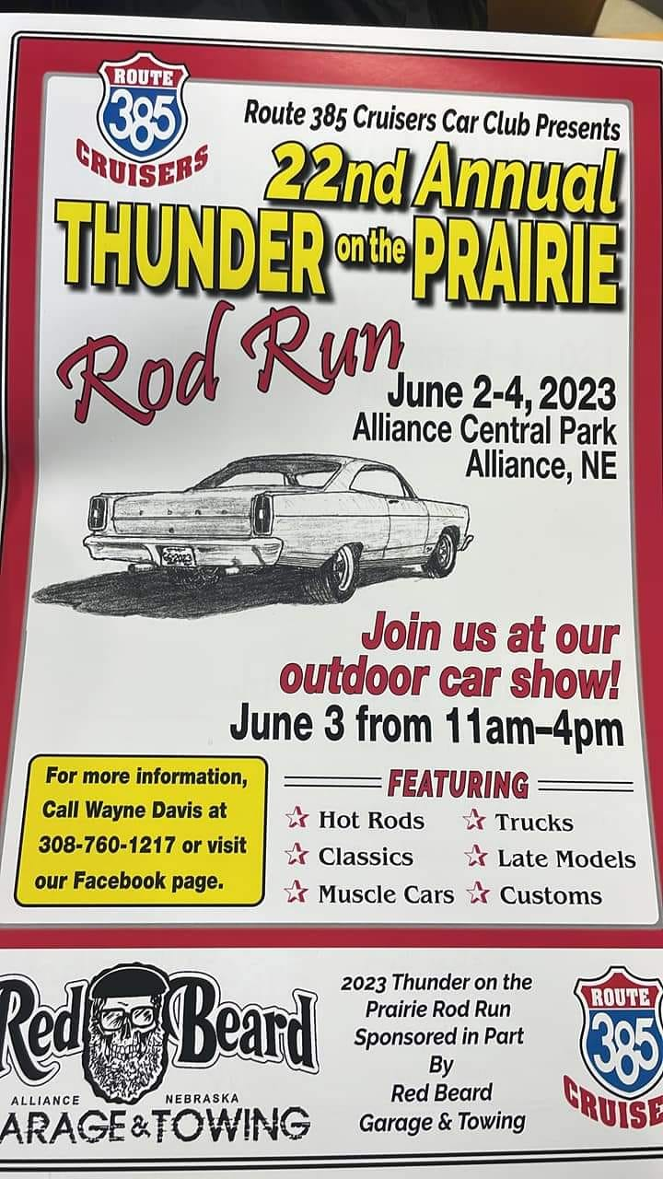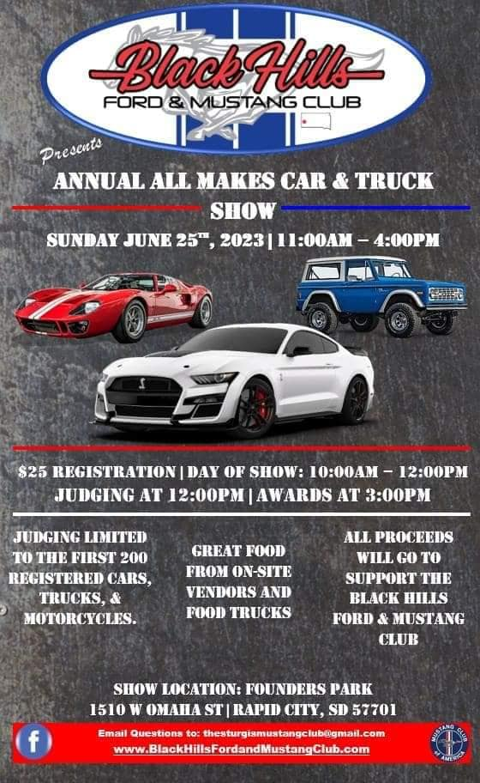

Sincerely, your Counts Car Club Communications Subcommittee Terry Broadley and Dick Towne

